Dreame Bot L10s Ultra Robot Vacuum and Mop with Self-Cleaning and Auto-Empty
FAQ V1.0

Contents
Contents 1
General 4
What is the Dreame L10s Ultra Robot? 4
What are the feature of Dreame L10s Ultra? 4
What is LDS laser navigation? 5
What is the advantage of the LDS laser navigation? 5
What is the advantage of the AI Visual Sensor? 5
What’s the function of the line laser? How do I use it? 5
● Product Introduction and User Guide 5
What are those buttons on the robot vacuum for, and how do I use it? 5
What are those buttons on the robot vacuum for, and how do I use it? 6
How to connect robot with Dreamehome or Mi Home App? 6
How to reset Wi-Fi with Dreame L10s Ultra robot? 7
How to use the Spot Clean function with Dreame L10s Ultra robot? 8
How to use the Do-Not-Disturb mode with the robot? 1
How to use the scheduled clean-up feature with Dreame L10s Ultra robot? 1
How to save a map with the Dreame L10s Ultra robot? 1
How to use the Advanced Map function with the Dreame L10s Ultra? 1
How does the L10s Ultra clean up the entire house? 1
Can Dreame L10s Ultra connect to the Base all the time? Is there overcharge protection? 2
What is the size of Dreame L10s Ultra? 2
How long does it take to charge Dreame L10s Ultra fully? 2
What battery does the Dreame L10s Ultra use？ 2
Does Dreame L10s Ultra have a motor overload protection? 2
Does Dreame L10s Ultra have any consumables that require maintenance regularly? 2
● Installation and Maintenance 3
Some tips before using 3
How to use the Auto-Empty Base? 3
How to charge the Dreame L10s Ultra? 4
How to use the Mopping Function with Dreame L10s Ultra? 4
How does the Dreame L10s Ultra return to the Base for charging? 5
How to clean the main brush of the Dreame L10s Ultra? 5
How to clean the dust and filter of the Dreame L10s Ultra? 6
How to clean the omnidirectional wheels of the Dreame L10s Ultra? 7
How to clean the side brush of the Dreame L10s Ultra? 7
How to do the routine maintenance for the robot vacuum? 7
How to replace the Dust Collection Bag 8
How to do the routine maintenance for the Base Station? 10
How to maintain the battery of Dreame L10s Ultra? 11
How should I upgrade the firmware of the robot? 11
How to restore to factory settings with the robot? 11
● FAQs 12
How to deal with the Wi-Fi network configuration failure? 12
Why does the Dreame L10s Ultra fail to charge? 12
What should I pay attention to before cleaning with the robot? 12
Do I need to update the firmware whenever there is a new version released? 12
Why does the robot start to clean the next zone before finishing the current one? 12
Why does robot repeat its cleaning path? 12
Why does L10s Ultra make strange sounds during cleaning? 13
What should I do if the Dreame L10s Ultra is trapped during cleaning? 13
What should I do if the Dreame L10s Ultra gets stuck when trying to pass through some house furnishings? 13
What should I do if the side brush or main brush is entangled during cleaning? 14
What should I do if the robot is entangled with the power cable of the Base? 14
Why does the Dreame L10s Ultra fail to relocate itself? 14
Why is the obstacle avoidance performance of the robot not good? 14
Why does L10s Ultra fail to power on? 15
Does L10s Ultra consume any power when connected with the Base? 15
Why does the robot fail to return for charging? 15
Why couldn’t I open the dust bin? 15
Why do I smell the odor from the mop? 16
Why does the robot Ultra fail to do schedule clean? 16
Why does robot fail to resume cleaning after recharging itself? 16
Why does the performance of robot fade with missed debris on the floor? 16
Why does the L10s Ultra fail to upgrade the firmware? 16
Why does Mi Home/Dreamehome App fail to load the cleaning data？ 16
How to prevent the robot vacuum from cleaning the carpet? 17
Why is the map different than before? What should I do if the map is distorted, inclined, or overlapped? 17
What should I do if the map configuration is not correct? 17
Why is the Carpet Boost function unstable? 17
Why does the L10s Ultra use a single-sided brush instead of a double-sided brush? 17
Can I use L10s Ultra to clean carpets? 17
What should I do if the Dreame L10s Ultra gets stuck when trying to pass through a narrow space? 18
Why does the battery decrease rapidly during cleaning？ 18
How to adjust the humidity of the mop pod？ 18
Why does the robot turn off automatically？ 18
Why does Mi Home/Dreamehome App indicates that the robot is offline？ 18
When cleaning the mop, the sewage tank cannot take out the sewage or it is prompted to report that the water level of the washboard is abnormal. How to deal with it? 19
How to deal with error related to the clean water tank when doing the self-wash? 19
How to deal with error related to the used water tank when doing the self-wash? 19
Why does the mop fall off easily? 20
Why are there marks on the ground after mopping? 20
What should I do if the dust collection is failed？ 20
Why do the used water tank and the washborad have a bad smell? 20

General

What is the Dreame L10s Ultra Robot?
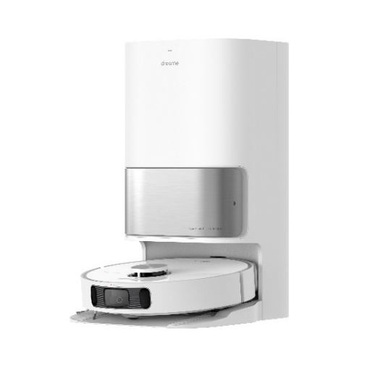
Take automatic cleaning to a whole new level with L10s Ultra, a fully automated robot vacuum that cleans floors and cleans itself. Dreame Technology's most advanced all-in-one cleaning robot of 2022 provides hands-free whole-home cleaning like never before. L10s Ultra's myriad of cutting-edge technologies combines dust collection, mop washing and drying, water and detergent adding, advanced AI-powered navigation, and more to make daily home cleaning fully automatic. Stop cleaning your home and start enjoying it.

What are the feature of Dreame L10s Ultra?

- A fully automated base station empties the robot's dust box, cleans and dries the mop pads, adds water and cleaning solution, and more.
- Advanced mapping, obstacle avoidance, navigation, and automatic cleaning strategy creation using dual lasers, an RBG camera, and powerful AI.
- Impressive hard floor and carpet cleaning ability with up to 5,300Pa of suction pressure, automatic suction adjustment, and a brand new rubber brush that is specifically optimized for carpet cleaning.
- Advanced mopping ability with proactive pressure and 180RPM dual rotary mops.
- Customizable suction level, mop dampness, and cleaning plans via the app.
- Voice control supported with Alexa and Google Assistant.

What is LDS laser navigation?
LDS laser navigation technology measures the relative position of the boundary and the robot vacuum by emitting the invisible laser and receiving reflected light. Based on this, the robot’s position in the map is determined, and a complete cleaning map is built.
The Dreame L10s Ultra is equipped with professional lidar sensors, which can scan up to 2,080 points per second with a scanning range of up to 8 m and an accuracy of 10 mm.

What is the advantage of the LDS laser navigation?
The LDS laser navigation is faster in creating the map and more precise in locating than the vSlam. It also supports more map operation options.

What is the advantage of the AI Visual Sensor?
The advanced AI Action utilizes an RGB camera and LiDAR navigation to rapidly learn your home, tailor cleaning strategies, and auto-generate paths according to the type of obstacle, flooring, and room. Get cleaning sooner with fast mapping that generates a 3D map of your home.

What’s the function of the line laser? How do I use it?
The line laser on the robot vacuum helps recognize its surroundings and obstacles, which then enables the vacuum to accurately avoid bumping and reduce the probability of entanglement, stuck and accidentally riding on small objects.
The function of obstacle avoidance is turned on by default. Users can change its status manually via settings on the APP.

● Product Introduction and User Guide

What are those buttons on the robot vacuum for, and how do I use it?
Please refer to the table below:
Function | Operation
Spot Cleaning Button  | · Press and hold for 3 seconds to turn on or off  · Press briefly to start cleaning after the robot is turned on
Dock Button  | · Press briefly to send the robot back to the base station  · Press and hold for 3 seconds to disable Child Lock
Spot Cleaning button | · Press briefly to start spot cleaning
Status Indicator | Status Indicator  · Solid White: Cleaning or cleaned  · Quickly Blinking Orange: Error  · Solid Orange: Low battery or paused

What are those buttons on the robot vacuum for, and how do I use it?
Function | Operation
Leave Button  | Briefly press to make the robot leave the base station
Clean Button  | Briefly press to make the robot clean all areas
Dry Button  | Briefly press to make the base station start or stop drying the  mop pads
Press and hold the and buttons for 3 seconds to activate or deactivate
Child Lock. After Child Lock is activated, all buttons on the robot and the base
station are locked.

How to connect robot with Dreamehome or Mi Home App?

1. Scan the QR code to download the Dreamehome or Mi Home App

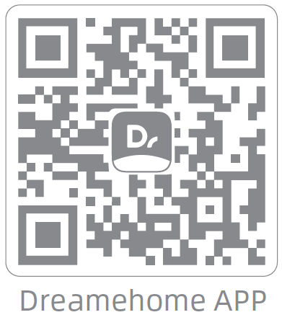
2. Add Device
Mi Home/Xiaomi Home APP: Open the Mi Home/Xiaomi Home app, tap "
" in the upper right, and scan the QR code above again to add "Dreame Bot
L10s Ultra". Please follow the prompts to finish the Wi-Fi connection.
Dreamehome APP: Open the Dreamehome app, tap " " in the upper right
to go to the "Add Device" page, and then select "Dreame Bot L10s Ultra".
Please follow the prompts to finish the Wi-Fi connection.
3. Reset Wi-Fi
Simultaneously press and hold the buttons and until you hear a voice
prompt saying, “Waiting for the network configuration.” Once the Wi-Fi
indicator is blinking slowly, the Wi-Fi has been successfully reset.
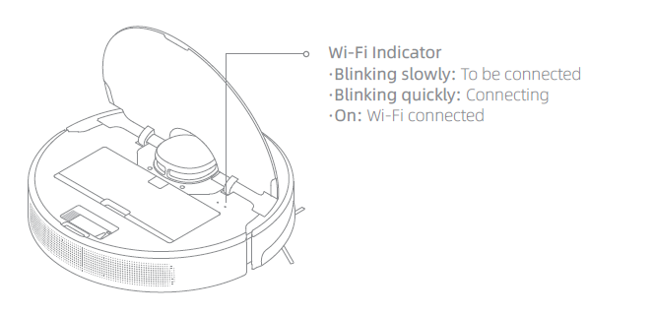
Note: If your robot cannot connect to the app successfully, reset the Wi-Fi and
add the device again.

How to reset Wi-Fi with Dreame L10s Ultra robot?
Open the top cover and observe the Wi-Fi indicator LED. Then press and hold the Spot Clean button and Dock button until hearing a voice prompt of "waiting for network configuration.”
When the Wi-Fi indicator starts to flash slowly again, it means the Wi-Fi reset is successful.

How to use the Spot Clean function with Dreame L10s Ultra robot?
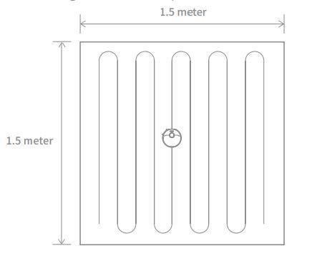
When the robot is paused or in Standby Mode, press and hold the button for 3 seconds to start Spot Clean Mode. In this mode, it will clean a square-shaped area of 1.5×1.5 meters directly around the robot. When the spot cleaning is done, the robot will automatically return to its original location and power off.
Note: Activating Spot Clean Mode will end the current cleaning task of the rob

How to use the Do-Not-Disturb mode with the robot?
DND mode is enabled by default from 10:00 pm to 08:00 am. You can disable or edit DND mode with the Mi Home or Dreamehome app. The robot will stop cleaning and voice reporting during the DND period, and the power indicator is off.

How to use the scheduled clean-up feature with Dreame L10s Ultra robot?
Users can set the schedule clean-up via the APP.
Then, the robot vacuum will automatically start cleaning at the scheduled time and return to the charging base once the cleaning is finished.

How to save a map with the Dreame L10s Ultra robot?
When the robot is charging on the Base, launch the Mi Home app, tap to start cleaning, and L10s Ultra will automatically learn about the surrounding environment and build up a complete map after several tasks. Please open all room doors during cleaning to keep the map consistent and complete.

How to use the Advanced Map function with the Dreame L10s Ultra?
Launch the Mi Home app, tap to start cleaning, and L10s Ultra will automatically learn about the surroundings and begin building a complete map, where you can access Auto Zone, Area Editor, Zoned Cleanup, Designated Cleanup, Virtual Wall, and other functions.

How does the L10s Ultra clean up the entire house?
When started initially, the robot will clean along the edge of an area by 4.5*4.5m, then clean the inner part by S-shape path until covering this area. After the area is clean, it will clean all other rooms in your house by the same principle.
After generating the map, the robot will clean the rooms by the order which edge cleaning first, then S-shape path cleaning until covering all rooms. It is an efficient way to prevent any missed areas.After cleaning, it will return to the Base automatically.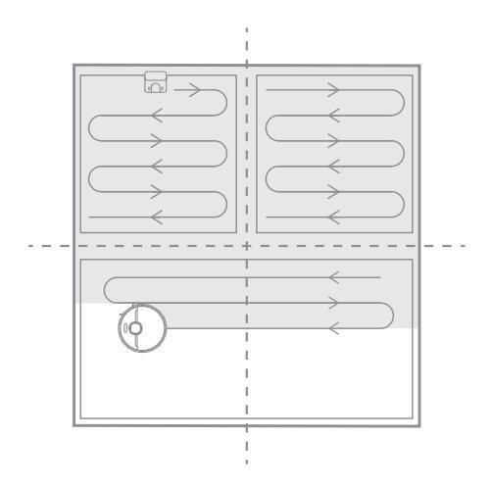

Can Dreame L10s Ultra connect to the Base all the time? Is there overcharge protection?
Yes. The robot supports overcharging protection and will disconnect automatically once fully charged.

What is the size of Dreame L10s Ultra?
The dimension of the Robot is 350*350*97mm;
The dimension of the Auto-Empty Base is 423*340*568mm.
The dimension of the package is 487*400*640mm

How long does it take to charge Dreame L10s Ultra fully?
It is about 6 hours.

What battery does the Dreame L10s Ultra use？
It is a 5200mAh high-performance Li-Po battery pack

Does Dreame L10s Ultra have a motor overload protection?
Yes. Dreame L10s Ultra has overload protection for all motors on-board, including the suction module, main brush, side brush, and main driving wheel. Motor overload protection is on once the robot is severely clogged with debris or foreign matters.

Does Dreame L10s Ultra have any consumables that require maintenance regularly?
Consumables | Suggested Maintenance
Main Brush | Clean weekly and replace every 6-12 months
Filter | Clean weekly and replace every 3-6 months
Side Brush | Clean weekly and replace every 3-6 months
Mop | Wash after the cleaning and replace every 1-3 months
Dust Collection Bag | 1-2 months

● Installation and Maintenance

Some tips before using
1. Before using the new machine, please remove the protective bag/protective film and the protective strips on both sides of the main body striking plate.
2. The base station should be placed against the wall at 5cm left and right / 1 meter in front without any obstacles. The upper cover should be opened to facilitate taking out the water tank, and the Wi-Fi signal is good.
3. When building a map for the first time, it is recommended to fully charge it first to avoid the power being too low to complete the work; it is recommended that you open the door of your home first and clean up the scattered items on the ground.
4. The machine needs to start from the base station. Do not interfere with the machine when the map is completed. After the cleaning is completed and it returns to the charging stand, the machine will automatically save the map.
5. For a better obstacle avoidance experience, turn on the "AI Smart Recognition" button before use, and wipe the AI lens in time to ensure that there are no fingerprints or dust.

How to use the Auto-Empty Base?
Place the base on level ground against the wall and connect it to a power
outlet. Place the robot onto the base to charge. The robot will turn on
automatically and begin charging. It is recommended to fully charge your
robot before first-time use.
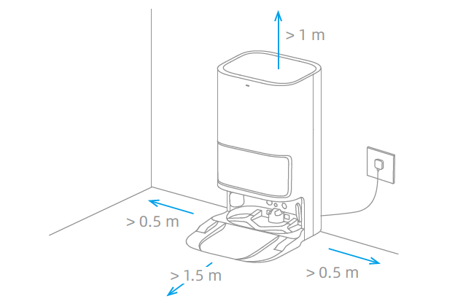
Note:
· Make sure that no objects might block the signaling area.
· To prevent water stains from wetting wood floors or carpets, placing the base
station on tile floors or marble floors is recommended

How to charge the Dreame L10s Ultra?
Press and hold the button on the robot for 3 seconds to turn it on. Place
the robot onto the base station with the mop assembly facing toward
the washboard. Then you will hear a voice notification when the robot
successfully connects to the base station and starts charging. After the robot
is fully charged, the status indicators on the robot and the base station will
remain lit for 10 minutes and will then dim.

How to use the Mopping Function with Dreame L10s Ultra?
It is recommended that all floors are vacuumed at least three times before the first mopping session to achieve a better cleaning effect.
1) Install the Side Brush and the Mop Assembly
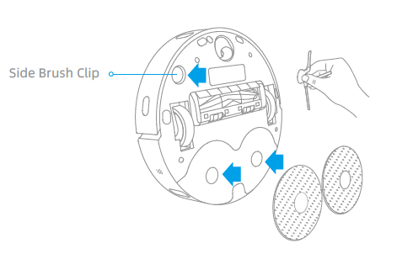
2) Install the Cleaner Bottle
Remove the cap of the cleaner bottle, and tear off the seals on the upper and
bottom of the bottle. Open the upper cover of the base station and take out
the clean water tank and the used water tank. Install the cleaner bottle along
the slot into place. The cleaner will be added automatically while working.
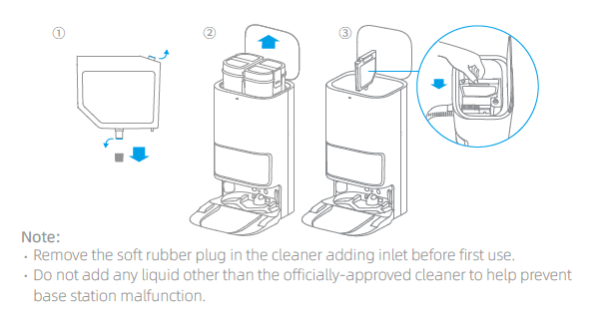

3) Add Water to the Clean Water Tank
Fill the clean water tank with clean water up to the maximum water level
mark, and then install the clean water tank and the used water tank in place.
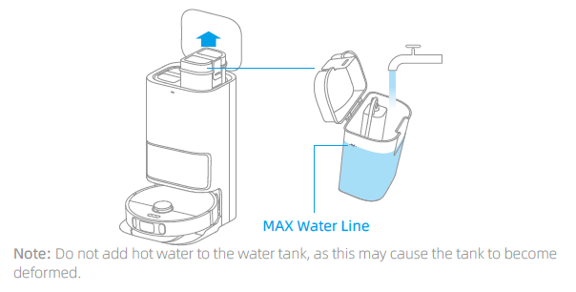

How does the Dreame L10s Ultra return to the Base for charging?
After the cleaning, the Robot will return to the Base for charging automatically.
Press the Dock button when the Robot is under Pause status.
When the Robot is charging, the power button will flash in colors: battery>15% with White and battery <15% with Orange.

How to clean the main brush of the Dreame L10s Ultra?
- Face the bottom of the robot, Press the brush guard clips inwards to remove the brush guard and lift the brush out of the robot.
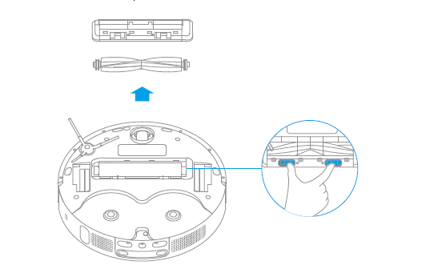
- Pull out the brush covers as shown in the diagram. Use the provided cleaning tool to remove the hair tangled in the brush.
- 

How to clean the dust and filter of the Dreame L10s Ultra?
1.Open the robot cover and press the bin clip to remove the dust bin.
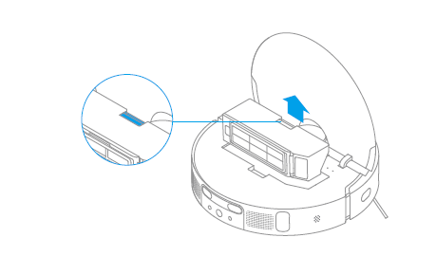
2.Open the bin cover and empty the bin as shown in the diagram.
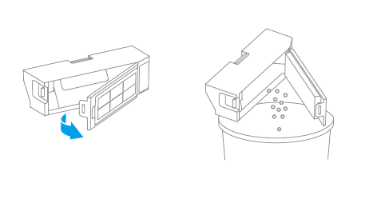
3.Remove the filter and tap its basket gently.
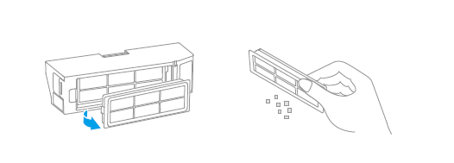
Note: Do not attempt to clean the filter with a brush, a finger or sharp objects to
prevent damage.
4. Rinse the dust bin and filter with water and dry them completely before
reinstalling.
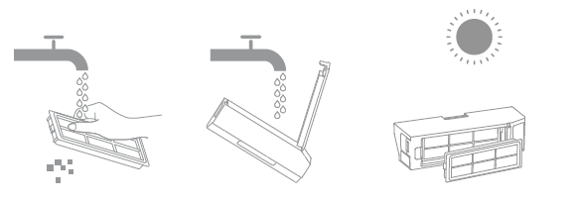

How to clean the omnidirectional wheels of the Dreame L10s Ultra?
1.Turn the robot over and pull the wheels upward.
2.Clean the hair and dirt on the wheels and axles.
3.Re-install the wheels by pressing them firmly down.
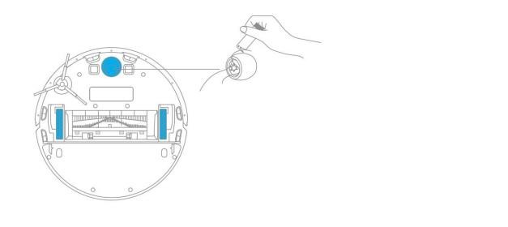
Note: Wheels can be rinsed with running water. Make sure to dry up before use.

How to clean the side brush of the Dreame L10s Ultra?
1. Turn over the robot, pull out the side brush and clean it up as shown below.
2.Re-install the side brush.
Tip: It is recommended to clean the side brush once a month and replace it every 3-6 months for better clean performance.
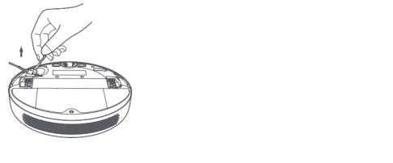

How to do the routine maintenance for the robot vacuum?
Use soft dry cloth to wipe the parts, which includes:
1.Four cliff sensors at the bottom
2.The infrared deceleration sensor in the front
3.The electric pole at the bottom
4.Motion tracking sensor at the bottom
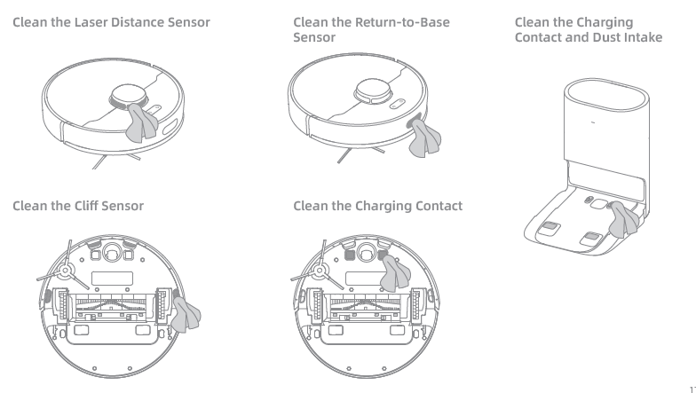

How to replace the Dust Collection Bag
Dust Collection Bag
When the dust collection bag needs to be replaced, a notification will appear
in the app.
- Discard the dust collection bag.
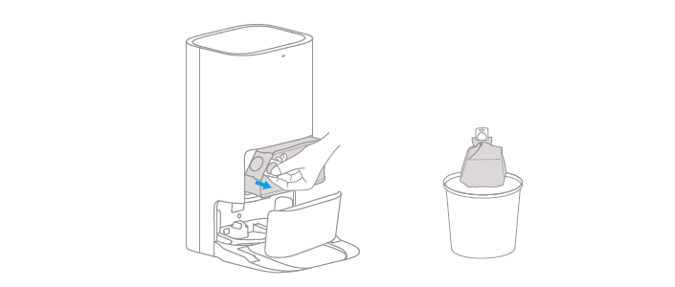
Note: Pulling upwards on the handle will seal the bag to prevent the dust and
debris from accidentally falling out.

2. Remove the dust and debris from the filter with a dry cloth.
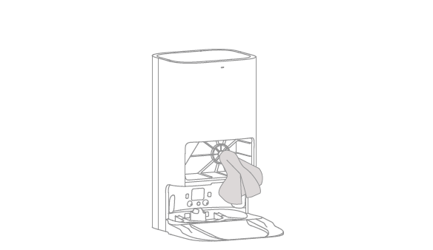

3.Install a new dust collection bag.
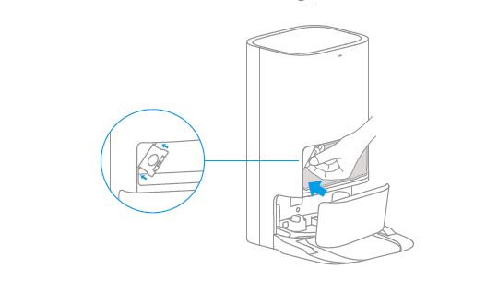
4. Close the cover of the dust cabinet.
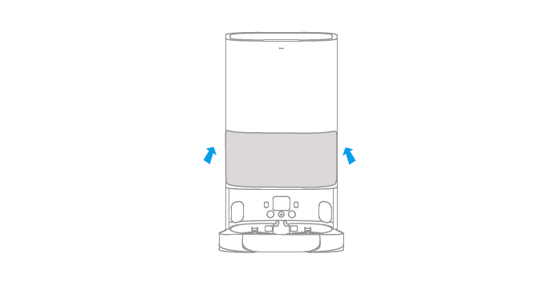

How to do the routine maintenance for the Base Station?
- Used Water Tank
1. Remove the used water tank, open its cover and pour out the dirty water.
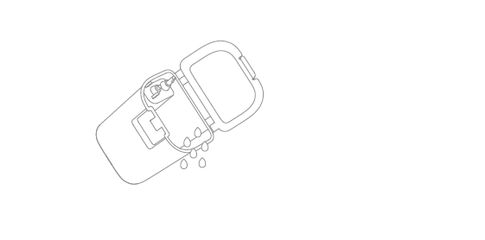
2. Rinse the used water tank with clean water, and use the provided cleaning
brush to clean the inner wall of the used water tank.
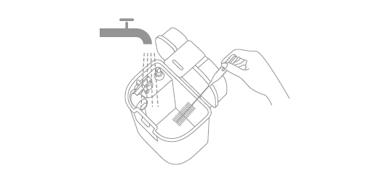
Note: The float ball in the used water tank is a movable part. Do not apply too
much force when cleaning it to avoid damaging it.
- Charging Contacts
Clean the charging contacts and the signaling area of the base station with a
soft, dry cloth.
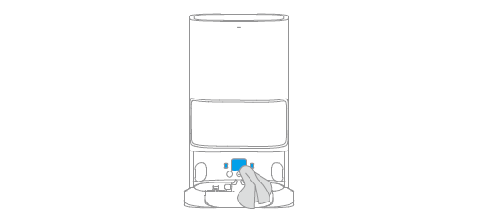
- Auto-empty Vents
Clean the auto-empty vents of the robot and the base station with a soft, dry
cloth.
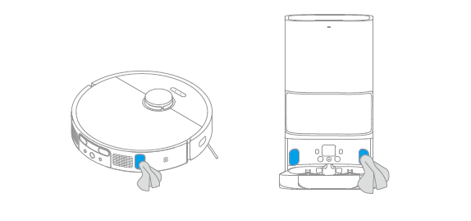
- Cleaner Adding Inlet
If the cleaner adding inlet is dirty, wipe it with a soft, dry cloth.
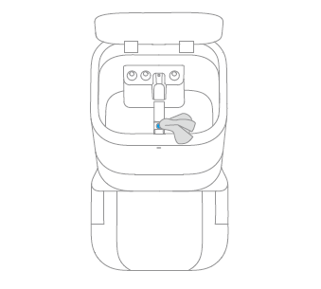
- Mop Pad
Remove the mop pad from the mop pad holder to replace it.
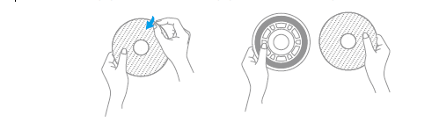

How to maintain the battery of Dreame L10s Ultra?
The robot contains a high-performance lithium-ion battery pack. Make sure that the battery remains well-charged for daily use to maintain optimal battery performance. If the robot is not used for an extended period of time, turn it off and put it away. To prevent damages from over-discharging, charge the robot at least once every three months.

How should I upgrade the firmware of the robot?
It can be done by Mi Home or Dreamehome APPs (please make sure the robot is on the Base and the battery is over 15%).
The buttons on the robot will flash rapidly during the Whole process.

How to restore to factory settings with the robot?
A: If robot still fails to operate normally after restarting, press and hold the reset button with a tool until hearing the voice prompt “start to restore factory settings.”
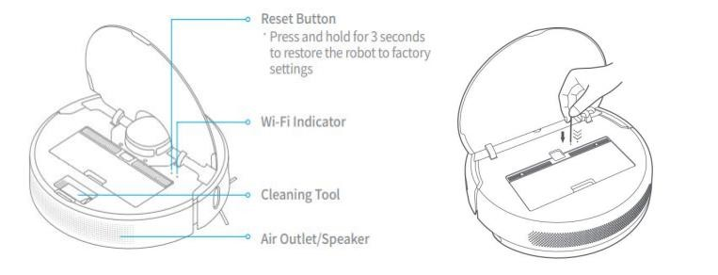

● FAQs

How to deal with the Wi-Fi network configuration failure?
The Dreame robot only supports 2.4G Wi-Fi network and does not support 5G Wi-Fi network. You can simply check it according to the following:
1. When the device is connected to the network, it is recommended to place it in a place with a strong Wi-Fi signal.
2. Please turn on the location permission of the mobile phone before configuring the network and have authorized the APP to use the location permission.
3. When connecting to the hotspot released by the robot, after hearing the voice broadcast by the robot, return to the App and wait for the network configuration result
4. It is recommended to set the home Wi-Fi name and password to English or numbers, and it is recommended not to use special characters,
5. The connection failure may also be related to the model of the mobile, you can try to use other different models of mobile phones to do the connection
If the above method does not work, you can try to use another mobile phone to open the hotspot and try again.
For further assistance required, please kindly contact the Dreame Support Team.

Why does the Dreame L10s Ultra fail to charge?
Please clean the charging interface of the Base and the robot if there is any dust on it, as dust may result in charging failure.

What should I pay attention to before cleaning with the robot?
Make sure the robot is fully charged before cleaning. Tidy up the space, put away fragile items and objects on the floor before cleaning.

Do I need to update the firmware whenever there is a new version released?
Each new firmware update is an optimization. Please update in time to ensure the best cleaning experience.

Why does the robot start to clean the next zone before finishing the current one?
After the first mapping, Dreame L10s Ultra will clean your home by room. If this issue occurs, check the zone settings in the app and adjust the settings if any errors arise.

Why does robot repeat its cleaning path?
Dreame L10s Ultra will follow the most effective cleaning path to clean your home. It may look repetitive when the robot navigates itself from the cleaned area to an uncleaned one, but it is not repeating the work.

Why does L10s Ultra make strange sounds during cleaning?
Loud and abnormal working sound
• Work loudly:
1. Check whether the suction is set to high suction in the APP. As the suction increases, the working sound will also increase.
2. If the carpet boost mode is turned on, the robot will automatically increase the suction after identifying the carpet, and the working sound will also increase.
• Unusual sound when working
1. Please remove the side brush, main brush cover, main brush and the mop pad holder at the bottom of the robot and observe after starting the cleaning.
If the working sound returns to normal:
① Install the side brush first, start the robot, if there is abnormal noise during operation, check whether the side brush is deformed.
②If the side brush works normally after being installed: The rubber strip of the main brush cover and the floor have friction with each other, and you can keep using it for several times to observe.
③If there is abnormal noise after installing the main brush, please remove the main brush and check whether the two ends of the main brush are entangled. When installing the cover, pay attention to the four sides being installed correctly.
The working sound is not back to normal:
① After the power is turned off, press down on both sides of the drive wheel and slide the drive wheel to check whether it can rotate, whether it can rebound after letting go, and clean it up.
②Turn the universal wheel to check whether it is smooth, if not, please clean it up.
③If the filter element is washed with water, please ensure that it is completely dry before use. The undried filter element will cause abnormal noise when the robot is working.

What should I do if the Dreame L10s Ultra is trapped during cleaning?
When cleaning, the robot may get stuck by slippers, plastic bags, and other clutters. Remove the clutters and put the robot back to the cleaned area close to the interrupted point. Please clean up clutters on the floor to prevent the robot from getting stuck during cleaning.

What should I do if the Dreame L10s Ultra gets stuck when trying to pass through some house furnishings?
During the Cleaning, if the robot meets the bottom of the furniture, which has a similar height to the robot, it may get stuck.
Please kindly purchase the magnetic stripes to avoid this issue. If not, please place some obstacles at the bottom of the furniture to prevent the robot from entering again.

What should I do if the side brush or main brush is entangled during cleaning?
When cleaning, the side brush and main brush may be entangled by power cords or charging cables on the floor.
Please try to place the host in the cleaned area nearby to continue cleaning after tidying up the cables.
Please clean up clutters on the floor to prevent the robot from tangling during cleaning.

What should I do if the robot is entangled with the power cable of the Base?
Please tie the excessive power cord of the Base with a strap before cleaning. Do not put it on the floor.

Why does the Dreame L10s Ultra fail to relocate itself?
After the machine prompts that the positioning failed, if the base station has not moved, you can put the robot back to the base station in time, and the robot will automatically restore the map. If the map fails to restore, you can start cleaning again.Once the cleaning is complete, the map will be saved after automatic recharging.

If the location of the base station has moved, or the surrounding environment has changed greatly, the robot will have a certain probability of failure to locate.If the ground is wet and the drive wheel slips or the robot is trapped, it may fail to locate; you can check according to the specific usage.

For a better user experience, it is recommended not to follow the robot closely when the robot is working. Use the minimum water output to mop the floor when the ground is wet or on tiles. Before the it works, you can pack up scattered objects, wires and other items, and you can also enable functions such as virtual walls/restricted areas to avoid the robot being trapped.
If you have saved multiple maps, when the robot enters the corresponding map, the APP needs to switch to the corresponding map, otherwise it will cause the positioning failure.

Why is the obstacle avoidance performance of the robot not good?

1. The robot can detect obstacles and decelerate and collide in advance. However, for some darker, reflective, smaller legs of desks and chairs, and some shorter obstacles, it may not be detected, and it is normal that the speed is not decelerated in advance.
2. Check whether the APP has the "AI smart recognition" button turned on,and regularly wipe the AI Visual Sensor with a soft dry cloth to ensure that there are no fingerprints or dust.
3. When curtains are flexible obstacles or the door is closed, the machine will slow down and touch and collide, which is a normal phenomenon;
4. Insufficient light in the working environment will affect the effect of AI visual recognition. It is recommended to use this function in sufficient light;
5. The home environment is complex, which may cause AI recognition to take a long time. It is recommended to clean up the home environment;
6. Our robot supports OTA online upgrade, and the pursuit will continue to optimize the robot's obstacle avoidance effect. It is recommended that you regularly check the firmware version and update it in time.

Why does L10s Ultra fail to power on?
L10s Ultra cannot be powered on in low battery. Please connect the L10s Ultra to the Base and confirm the working temperature is in the range from 0 to 50℃.

Does L10s Ultra consume any power when connected with the Base?
When connecting with the Base, the L10s Ultra is powered by the Base, while the built-in battery of the L10s Ultra will enter sleep mode with minimum power consumption to keep itself in the best performance.

Why does the robot fail to return for charging?
1.Please check whether the plug is loose to ensure that the charging base is powered on.
2. Please put the robot 1-2 meters in front of the charging base, short press the recharge button, if it cannot be recharged normally,
please connect with the support team for further help.
if it can be recharged, please confirm:
①The charging stand needs to be placed against the wall, it is recommended that the left and right sides are 5cm, and there should be no obstacles 1.5 meters in front;
②Away from signal interference, such as router TV, etc.
③There can be no mirror reflections on the opposite side, such as mirrors, windows, etc.
3. Please confirm that the robot is working from the charging stand, and whether the LDS laser sensor on the top of the robot rotates normally.
4. Please confirm whether the driving wheel of the robot is slipping, stuck or trapped during the working process.
5. If the above problems are eliminated, please try to restart the host and clean it again;
6. When you change the location of the base station, you need to place the robot on the base station, and then clean it from the base station.
7. If there is still a problem after restarting the robot, please try to reset the robot, change the charging stand to an open place, and try to clean it again.

Why couldn’t I open the dust bin?
Please refer to the marking on the cover to open the dust bin correctly. Do not open the dust bin by removing the filter.

Why do I smell the odor from the mop?
1. Please check whether there is accumulated water and dirt inside the Washboard, and whether the mop is clean
(1) In the initial use, the floor of the home environment is still relatively dirty. It is recommended to set the self-wash after cleaning for 10 square meters in the early stage, and then choose 20/30 square meters after several uses.
(2) Regularly adding special cleaning agent can also effectively improve the cleaning effect of mop
(3) If it is dragged to relatively dirty garbage or a mop for 2-4 weeks, it is recommended to remove it manually for cleaning
(4) If there is a need for temporary enhanced cleaning, you can click the cleaning rag button at any time in the middle of work to clean the rag immediately
2. Please confirm whether the residual water in the clean water tank has been left for too long, and please replace the clean water in time
3. Please check whether the dust box filter is dirty - please follow the instructions in the manual to maintain and clean the dust box filter.

Why does the robot Ultra fail to do schedule clean?
It might be caused by the low battery level. The scheduled clean only works when the battery level is higher than 15%.

Why does robot fail to resume cleaning after recharging itself?
Make sure the L10s Ultra is not working in the DND Mode. If you actively command it to return or manually move it back to the dock, L10s Ultra will not resume cleaning either.

Why does the performance of robot fade with missed debris on the floor?
1. When the dust box is full and the dust box filter has been blocked, please clean the dust box and filter in time, and it is recommended to automatically turn on the automatic dust collection function.
2. The main brush is entangled by foreign objects, please clean the main brush in time.
3. When the dust collection port of the robot is blocked by foreign objects, please clean the dust collection port in time.

Why does the L10s Ultra fail to upgrade the firmware?
Please kindly check the network connection and do the firmware upgrade with a stable network connection.
Please make sure the battery is over 15% before upgrading.

Why does Mi Home/Dreamehome App fail to load the cleaning data？
Check the network connection; Restart the app, and try again.

How to prevent the robot vacuum from cleaning the carpet?
Set the No-Go Zone around the carpet via the APP, and the robot vacuum will avoid the carpet while cleaning.

Why is the map different than before? What should I do if the map is distorted, inclined, or overlapped?
The map is distorted or overlapped:
Make sure the map is saved successfully, which means the parted sections are shown in the map, and the area cleaning can work properly.
Turn off the power and restart the robot vacuum. Then manually place the robot vacuum to the charging base and try to restore the map. If the restoration fails, replace the charging base position and redo the mapping.
Recommendations:
1.Properly place the base against the wall by making sure the open space beside the base should be at least 0.5m, and there are no obstacles 1m from the front of the base.
2.While the robot vacuum is working, please do not manually move the machine.
3.Strong light or highly reflective situations might cause the malfunction of the mapping.
4.We recommend closing the curtain or finding another time when the light is not so strong to clean. For highly reflective surfaces, it’s better to cover 15cm from the bottom of the surface while cleaning.
Users can reset the mapping, and the robot will remap during its next cleaning.
5. Regularly check and clean the navigation sensors with a soft cloth or tissue.

What should I do if the map configuration is not correct?
We could adjust the Map manually via the App.

Why is the Carpet Boost function unstable?
This function is still the beta version. Using the robot on the shorter carpet might cause the function failure.

Why does the L10s Ultra use a single-sided brush instead of a double-sided brush?
The L10s Ultra uses a single-side brush + main brush for cleaning. The single-side brush is mainly responsible for cleaning the garbage near the walls and furniture edges. Compared with the double-sided brush, it is easy to blow up the garbage when cleaning, and the double-sided brush is more likely to be entangled on the carpet.

Can I use L10s Ultra to clean carpets?
The L10s Ultra can clean some medium and short-pile carpets. Carpets that are too long are more likely to be sucked into the dust box, and the side brushes and drive wheels are easy to get stuck. At the same time, it is recommended that you set up "sweeping restricted area"/"sweeping restricted area" to avoid wetting the carpet.

What should I do if the Dreame L10s Ultra gets stuck when trying to pass through a narrow space?
L10s Ultra may get stuck when it tries to clean a narrow space, for example, the bottom of a closet that is close to its height. Magnetic stripes are provided to help set a virtual wall or you can block the narrow space with an obstacle to prevent L10s Ultra from entering.、

Why does the battery decrease rapidly during cleaning？
After L10s Ultra is charged and stored for a long time, it is normal for the battery to drop quickly in the first few minutes during cleaning. After this, the power consumption will return to normal. The battery will also drop faster in Turbo mode.

How to adjust the humidity of the mop pod？
Launch the device via Mi home App and adjust the humidity of the mop pod in cleaning mode.

Why does the robot turn off automatically？
The robot will turn off automatically when the battery is less than 2% or when it is not charging and has no operations in 12 hours.

Why does Mi Home/Dreamehome App indicates that the robot is offline？
1. When the robot is turned off, the APP cannot connect to the machine
2. The online and offline status changes of the robot are related to the strength of the network signal at the location where the robot is located. If the network signal at the location where the robot is located is weak or unstable, the robot will be offline.
3. There is no internet connection with your Wi-Fi.
You can solve it according to the following solutions:
1. Check whether the robot is in a shutdown state. If it is in a shutdown state, please press and hold the power key of the robot to turn it on, and then reconfigure the network;
2. Offline during normal operation of the robot will not affect the it to continue to complete the previous cleaning task. When the network signal is better, the robot will automatically return to the online state
3. You can add or reset the network to the robot, and put the router close to the robot to assign the network to the machine
4. Check whether the Wi-Fi works normally. If the Wi-Fi is abnormal, repair the it in time, and then configure the network again
5. Please check whether the 5G preference is selected in the distribution network settings of the machine, and you need to turn off this setting

When cleaning the mop, the sewage tank cannot take out the sewage or it is prompted to report that the water level of the washboard is abnormal. How to deal with it?

The abnormal water level of the washboard has a great relationship with the sealing performance of the sewage tank. It is recommended that you perform the following operations to ensure the sealing performance.
1. Please remove the washboard, check whether the sewage outlet is blocked and clean it in time and wipe the overflow sensor of the cleaning plate at the same time.
2. Before reinstalling the sewage tank, check whether the sealing ring of the sewage tank is loose or dirty. Be sure to reset it manually in time and wipe it with a rag.
3. After dumping the sewage, make sure the sewage tank clips are in place.
4. After the sewage tank is placed in the base station, press down lightly to ensure that the sewage tank is installed in place.
5. You can use a dry cloth to wipe the residual water inside the base and put the cleaning tray back in and observe it again.

How to deal with error related to the clean water tank when doing the self-wash?
It is recommended that you first check whether the clean water tank is installed correctly, or whether the water volume of the clean water tank is insufficient. If it is normal, you can check it according to the following steps:
1. You can take out the clean water tank and check whether the float at the bottom of the clean water tank and the float magnet are in place. If it is lost, please contact with dreame support team.
2. When the water in the clean water tank is not enough to complete the work, an exception will be displayed. After adding enough clean water, click the sweep and drag button on the base or the start button on the App to start cleaning
3. Please put the clean water tank in place again and press it gently to ensure the accuracy of the docking between the clean water tank and the base station;
4. If the water tank still reports a fault, please unplug the power supply of the base, wait for 1 minute, plug it in again, and try again
5. If the problem still exists, please contact with dreame support team.

How to deal with error related to the used water tank when doing the self-wash?
It is recommended that you first check whether the used water tank is installed correctly. If it is normal, you can check it according to the following steps:
1. If the sewage is full, please dump the sewage first
2. Check whether the float ball of the sewage tank floats normally, and check whether the magnet of the sewage tank is still there. If it is abnormal,please contact with dreame support team.
3. Click the APP start button to continue the cleaning task
If the problem persists, please contact with dreame support team.

Why does the mop fall off easily?
It is recommended that you observe that the mop is well fitted on the mop tray before using it. After many uses, the mop cannot be attached properly or is uneven, so you need to replace it with a new mop in time.

When the robot is taken from the base station, the mop pod may be stuck. It is suggested that you can use the Leave Button on the base station and Dock Button on the robot to control the it in and out of the base station

When the robot climbs over the carpet, threshold, or small steps, the rag tray may be trapped, causing the rag tray to fall. It is recommended that you set a mopping restricted area to prevent the sweeper from entering with a mop. And try to tidy up the ground power cord before cleaning to prevent the rag tray from falling off due to entanglement.

Why are there marks on the ground after mopping?
After the mopping is completed, the water on the ground evaporates, and it is normal to leave some water marks. The obviousness of the watermark has a lot to do with the floor material and light. It is recommended that the sweeper can be set to clean regularly and replace the rag in time. The ground will be cleaner and the water stains will become less and less obvious. It is recommended to use a special cleaning solution to make the floor tile floor cleaner and brighter.

What should I do if the dust collection is failed？
1. Ensure that the base station is powered on and the dust collection work is performed, the dust cover of the dust collection bin needs to be covered and the dust bag is installed;
2. Please check whether the dust bag is full. If it is full, replace the dust bag again.
3. Check the dust collection port of the robot and the base, and whether the dust collection outlet of the dust box is blocked. Please clean it before dust collection operation.
4. Please check whether the dust collection button of the APP is turned off. If it is turned off, please turn it on and try again.
5. Check that the transparent window at the charging pole piece is dirty, and it may not be able to transmit the signal. Please clean it with a dry paper towel and try again.
6. If the amount of dust and dirt in the home is large, it is recommended to set the frequency of dust collection to be every time after cleaning.

Why do the used water tank and the washborad have a bad smell?
1. When the ground is dirty, it is recommended to dump and rinse the sewage tank in time after each use.
2. Regularly clean the cleaning disk. It is recommended to use the mopping function every 2~3 times to clean the cleaning disk once

And the L10s Ultra is equipped with a base station self-cleaning function, you could follow the steps as below.
Base station self-cleaning process:
1. Short press the Leave Button to exit the robot from the base station.
2. Manually remove the washboard on the base.
3. Long press the Leave Button for 3s to perform self-cleaning of the base station, and the clean water pump discharges water.
4. Use brush to clean the base station.
5. Press and hold the Leave Button again for 3s to pump dirty water.
6. Gently wipe the smooth cleaning plate with a rag and put the cleaning plate back.
7. Short press the main unit recharge button to let the main unit automatically return to the base station for charging.

